The Staci Stephens Fund, Inc.
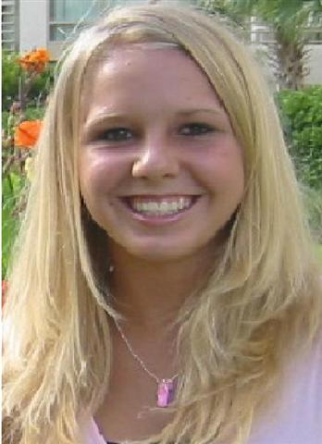
Staci Stephens was an exceptional student at Timber Creek High School. On March 13, 2005, she died unexpectedly from a virus (Viral Myocarditis) that enlarged her heart. To honor her memory, her parents, Barry and Kristen Stephens, have established The Staci Stephens Fund, Inc.

Staci passed away from Viral Myocarditis, suddenly and quickly. Upon arriving at the hospital, on Sunday Morning March 13, 2005, Staci was taken back to the ER to be evaluated. She was pale and lethargic. Her mom went to park the car and came into the ER. Her family thought she had a mild case of the flu and dehydration. However, the ER personnel came back a few minutes later to deliver the fateful news. Staci was not breathing. From this point on, we tried desperately to ask God to let Staci start breathing. We prayed, cried, and brought in many people to talk to her and try to bring her back to us. The emergency room personnel stood around her bedside, along with all of us, holding hands and praying trying to bring her back. Nothing worked. However, we were not as fortunate as some people that have survived Viral Myocarditis. We are hoping that we can help others so that they don’t have to experience what we have or help people that have been affected with heart related illnesses.
This grant is given with the prayer that those who receive it will work on a cure or diagnosis for heart related issues, make an impact on their campus, and live life trying to change hearts and souls.
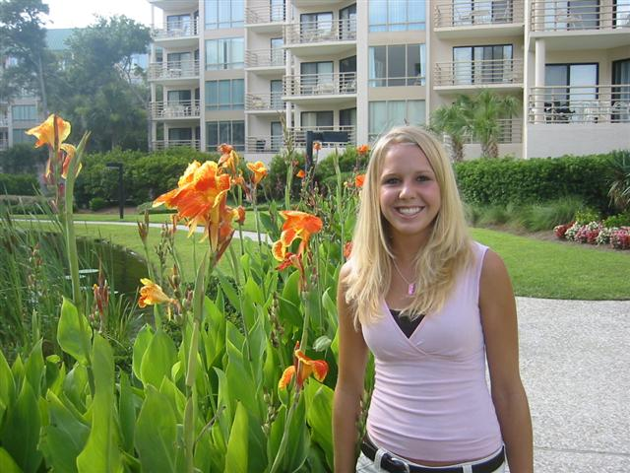
The Staci Stephens Fund, Inc.
Directions: Please fill this out creatively, neatly, thoughtfully, and completely on another sheet of paper.
Students Name:
Today’s Date:
Medical Condition:
Current Grade or Age:
Phone Number (home and Cell):
Email Address:
AIM ID:
Information:

Creatively, on a separate page, provide your response to the following questions:
- a) Did you personally know Staci? If so, what was your relationship with her? If not, have you been to the website, read her testimony, or seen the video? B) How did you hear about Staci’s story if you did not know her? C) Describe how Staci’s Story has impacted your life.
- What is your story? Can you write a few paragraphs of why you believe this grant would help you.

